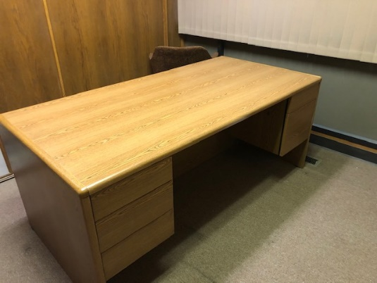
Oak colored desk - $ 250
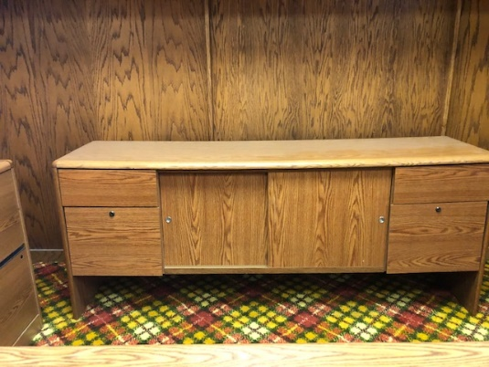
Oak colored credenza - $ 300
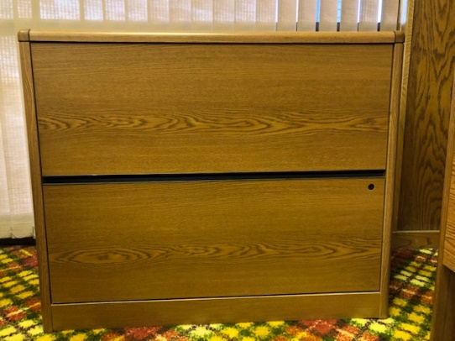
Oak colored file drawers - $ 200
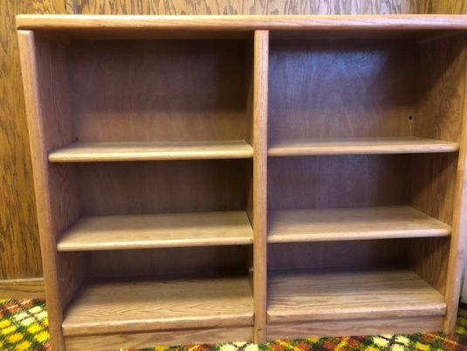
Oak colored shelves - $200
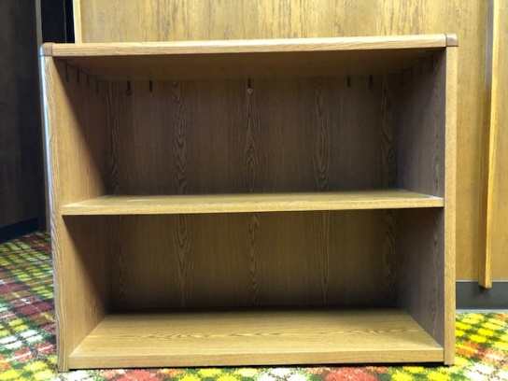
Oak colored shelves - $ 125
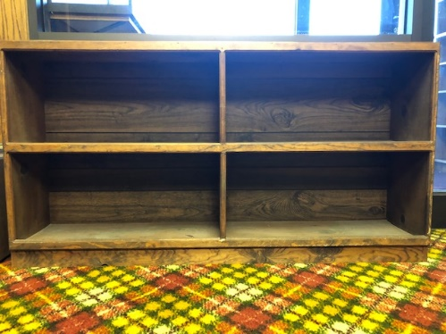
Brown colored shelves - $ 100
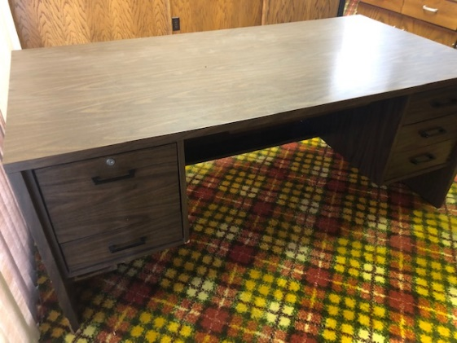
Brown colored desk - $ 200
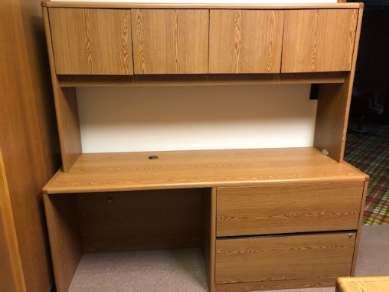
Oak colored workstation - $ 350

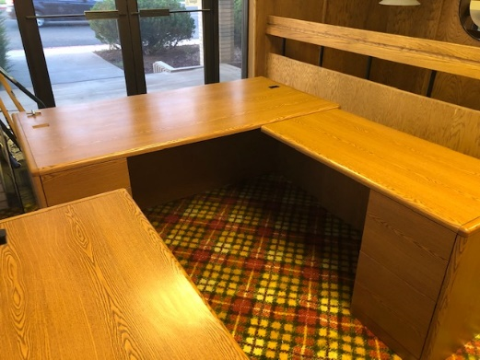
2 Oak colored L desks with right returns - $ 350 each
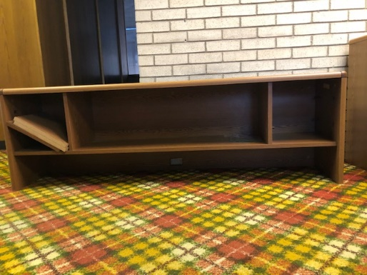
Oak colored shelves – sits on desk - $ 150
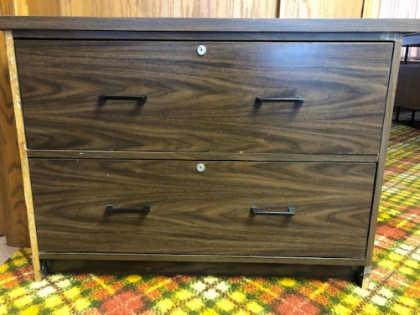
Brown file drawers - $ 50

All items are at the Caldwell, Coombs and Foley office building at 92 N Vernal Avenue, Vernal, UT.
To view and purchase items call for an appointment: Boyce Coombs (801) 641-6122 or Robert Foley (435) 790-2146.

