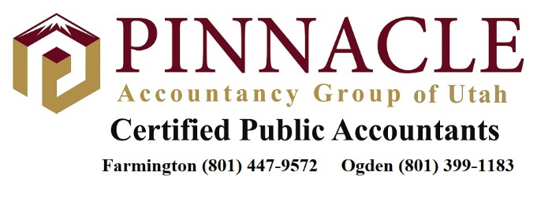

Staff Tax Accountant
Introduction:

This job is a permanent position. The position offers the opportunity to be mentored by Senior Accountants and CPAs in the fields of tax and accounting.

Position Summary:

The Staff Tax Accountant provides technical tax and accounting services for individual clients and organizations in accordance with regulatory, industry and company quality standards. Records and monitors time spent on client work. Reviews own work for compliance and quality and obtains information to ensure compliance and quality meet regulatory and company standards. The Staff Tax Accountant collaborates with other departments and organization members in conveying technical information, client information, and providing support to other organization members as necessary.

Qualifications and Requirements:

In pursuit of Master’s Degree in Accounting with a graduation date in 2021 or 2022
Plans to complete CPA exam upon graduation
Bachelor’s Degree in Accounting from an accredited college/university
Knowledge of regulations and laws as applies to accounting and tax activities
Client service experience to include: problem resolution, negotiations and providing recommendations
Strong research and organizational skills
Excellent verbal and written communications skills with the ability to articulate complex information
Experience handling multiple tasks
Detail oriented

Duties and Responsibilities:

Performs professional services to ensure client forms, documentation and processes comply with laws or other statutory requirements.
Schedules work activity to meet all project review due dates and regulatory due dates.
Reconcile bank statements.
Prepares payroll and related tax reports.
Performs data entry, journal entries and prepares spreadsheets.
Assists co-workers with special projects as required.
Reviews and resolves service related issues with clients, other staff members, or subject matter experts as necessary.
Performs quality control checks on work performed to ensure regulatory and company requirements are met prior to approving the work.

